History of AMD. First processors.

1. AMD Is Born
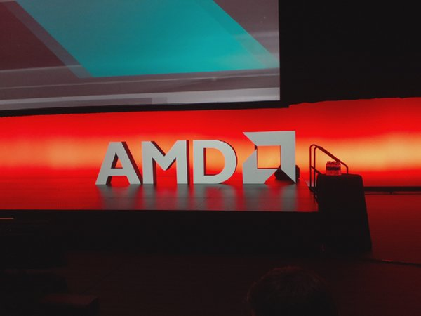
From its conception in 1969, AMD focused on producing microprocessors and similar computer components. Initially, it merely licensed processor designs from other companies like Fairchild Semiconductor. Although it started producing other PC components developed entirely in-house early on as well, AMD wouldn't produce a processor it designed itself for several years.

2. AM9080 And AM2900
In 1975, AMD created its first two non-licensed processor products. Technically, its AM2900 wasn't a processor; rather, it was a series of components used to build a 4-bit modular processor. It also produced the AM9080, which was a reverse-engineered clone of Intel's 8080 8-bit microprocessor.
The IBM Agreement
AMD's entry into the x86 processor market began in the early 1980s following an agreement between IBM and Intel. At the time, IBM was one of the largest computer manufacturers in the world and quite possibly the single largest producer of computer products. IBM was deliberating on several different processor designs to use in its upcoming products when it entered into negotiations with Intel. If Intel won the contract, it would secure a massive order for the company's processors for use inside of IBM-compatible PCs.
IBM was concerned, however, that the sheer number of processors that it needed would exceed the production capabilities of any single manufacturer, so it required Intel to license its technology to third-party manufacturers to ensure sufficient total volume. Intel, not wanting to lose the contract with IBM to a competitor, agreed to IBM's terms in 1981.
Following the agreement, AMD began producing licensed identical clones of Intel's 8086 processors in 1982.
Code Name | N/A
Release Date | 1982
Architecture | 16-bit
Data Bus | 16-bit
Address Bus | 20-bit
Maximum Memory Support | 1 MB
L1 Cache | None
L2 Cache | None
Frequency | 4 - 10 MHz
FSB | 4 - 10 MHz
FPU | 8087 (Sold Separate)
SIMD | None
Fab | 3000 nm
Transistor Count | 29
Power Consumption | N/A
Voltage | 5 V
Die Area | 33 mm²
Socket | 40 pins

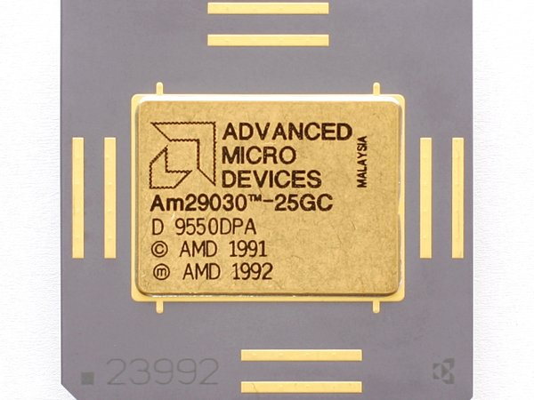
AM29000 32-Bit RISC Processors
Throughout the 1980s and into the 1990s, AMD also produced a line of 32-bit RISC processors known as the AM29000 series. These processors were essentially the next generation of its earlier AM2900 products, however, and they were targeted more at the embedded market than high-performance computers. AMD designed the AM29000 using a variation of the Berkeley RISC architecture. Eventually, AMD discontinued work on the AM29000 series to focus on its x86 processor line.
AMD AM286
AMD's second x86 processor was the AM286, a licensed clone of Intel's 80286. Although the chip was architecturally identical, it had one advantage over its Intel counterpart: higher clock speeds. Where Intel capped the 80286 at 12.5 MHz, AMD pushed the AM286 as high as 20 MHz.
AMD AM386: Legal Battles With Intel
In 1985, Intel released its first 32-bit x86 processor design, the 80386. AMD planned to release its variation, the AM386, not long after, but Intel held it up in court. Intel claimed that its cross-licensing agreement permitted AMD to produce copies of only the 80286 and older processor designs, but AMD argued that the contract permitted it to create clones of the 80386 and future x86 derivatives, as well. After years of legal battles, the courts sided with AMD, and the company was able to release its AM386 in 1991.
Although the AM386 is an 80386 clone, AMD released AM386 processors with clock speeds up to 40 MHz, whereas Intel's 80386 tapped out at 33 MHz. This gave AMD a performance advantage, and as it used the same socket and platform as the 80386, it gave customers an upgrade path to their aging systems.
AM486 And AMD 5x86: The Final Clone
The last processor designed by Intel that AMD produced was the AM486 (80486), and it was released in 1994. Due to ongoing legal disputes between Intel and AMD, some versions of the AM486 use Intel microcode whereas others use microcode developed in-house by AMD. AMD followed a similar strategy with its AM486 as it did with the AM386, by pushing clock speed considerably higher than Intel. Although Intel's fastest 80486 processors were capped at 100 MHz, AMD went as high as 120 MHz on the AM486.
Not long after, in 1995, AMD also released its AMD 5x86. This processor used the same architecture as the AM486 and 80486, but it pushed the clock speed even higher. Retail models ran at 133 MHz, and OEMs had access to an even faster 150 MHz version.
Other notable changes in this line of processors was the addition of L1 cache, which helped to increase performance compared to the older 80386/AM386 CPUs. It also moved the FPU into the same package as the CPU, which also significantly improved performance. Prior to this, all FPUs were sold as separate hardware units and connected to the CPU through the motherboard.
Following the release of Intel's first Pentium processor around the same time also lead AMD and other competing CPU designers to introduce the PR or "Pentium Rating" system. This gave companies a simple way to advertise their products against each other and against Intel's Pentium. An example of this is the AMD 5x86 PR 75, which was advertised as having equivalent performance to a 75 MHz Pentium CPU.
K5: AMD's First x86 Processor
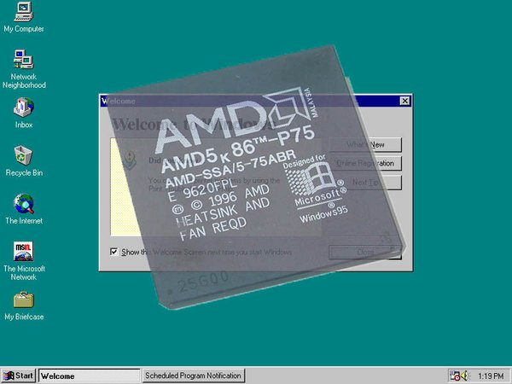
In 1996, AMD released its first x86 processor designed entirely in-house. The fifth-generation x86 K5 processor used an innovative design that combined the execution hardware from AMD's discontinued AM29000 RISC processors with an x86 front end. Because the execution back-end hardware was based on a RISC design, instructions were decoded into micro-instructions that could be fed into one of five integer execution units or an integrated FPU.
AMD implemented an out-of-order speculative execution design as well, which helped to boost performance. The overall design was fairly complex, however, which limited AMD's ability to push up the clock speed, and the K5 was not able to surpass Intel's Pentium in terms of performance. It was considered relatively efficient, however, and AMD advertised 100 MHz K5 processors with a PR133 rating, meaning that AMD considered it to have equivalent performance to a 133 MHz Pentium.

AMD K5
Code Name | SSA/5, 5k86
Date | 1996
Architecture | 32-bit
Data Bus | 32-bit
Address Bus | 32-bit
Maximum Memory Support | 4 GB
L1 Cache | 16 KB + 8 KB
L2 Cache | None
Clock Speed | 75 - 133 MHz (PR75 - PR200)
FSB | 50 - 66 MHz
SIMD | None
Fab | 500 - 350 nm
Transistor Count | 4.3 Million
Power Consumption | 11 - 16 W
Voltage | 3.52 V
Die Area | 181 - 251 mm²
Connection | Socket 5 & Socket 7

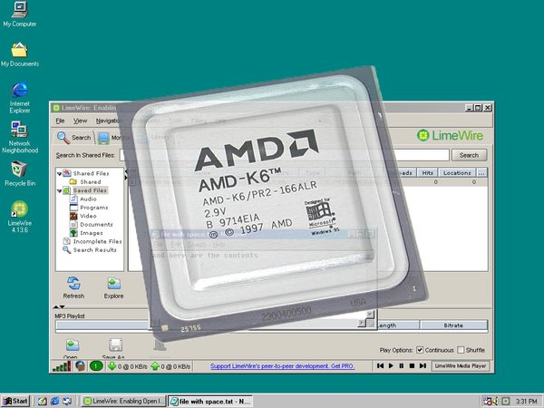
K6: AMD's NexGen Processor
Instead of developing a new architecture to succeed the K5, AMD opted to purchase NexGen, a competing manufacturer of processors, and use its upcoming Nx686 design for the K6. Although the design was completely different than the K5, it was somewhat similar at a high level.
For example, like the K5, the K6 also used an x86 front-end to decode instructions into micro-operations that were then executed on internally RISC-like hardware. The K6 was released in 1997, and it was compatible with Socket 7 motherboards; clock-for-clock, it matched the performance of Intel's Pentium II, while also being considerably less expensive. It also included the important MMX SIMD instruction set.
The Pentium II did have one major advantage in that its FPU performance was better than the K6.

AMD K6

Code Name | K6 (350 nm), Little Foot (250 nm)
Date | 1997/1998
Architecture | 32-bit
Data Bus | 32-bit
Address Bus | 32-bit
Maximum Memory Support | 4 GB
L1 Cache | 32 KB + 32 KB
L2 Cache | None
L3 Cache | None
Clock Speed | 266 - 350 MHz
FSB | 50 - 66 MHz
SIMD | MMX
Fab | 350 - 250 nm
Transistor Count | 8.8 Million
Power Consumption | 12 - 28 W
Voltage | 2,2 - 3,2 V
Die Area | 68 - 157 mm²
Socket | Socket 7
AMD K6-II
AMD's next processor was the K6-II. It was essentially an extended version of the K6 that could use a faster 100 MHz FSB, higher clock speeds, and new SIMD instructions. AMD introduced its 3DNow! SIMD instruction set as a competitor to Intel's MMX. Similar to AMD's older processors, the K6-II gave customers a clear upgrade path from the aging Pentium MMX processors, and as a result they were highly successful.
AMD K6-III: Integration Of L2 Cache
In 1999, AMD released its third-generation K6 processor, the K6-III. It was architecturally similar to the K6 and K6-II, but AMD added 256 KB of L2 cache on the CPU die. Prior to this, L2 was placed on the motherboard and accessed over the FSB, but the tighter integration significantly reduced latency and increased bandwidth. The K6-III was relatively expensive, however, and AMD quickly replaced it with the Athlon processor.
AMD K6-III
AMD K6-II+ And K6-III+
The last processors released by AMD in the K6 product line were the K6-II+ and K6-III+, which were targeted at the mobile market. These processors were similar to the K6-III in that they incorporated on-die L2 cache. The K6-II+ had 128 KB of L2, whereas the K6-III+ had 256 KB. Thanks to the use of AMD's 180 nm fab technology, these processors were relatively energy efficient.
AMD K7 And K75: The Birth Of Athlon
In 1999, AMD released its seventh-generation processor, the Athlon. It used a new architecture that increased IPC considerably and allowed AMD to push the clock rates up to 1 GHz. The FPU inside of AMD's previous processors had lagged behind competing Intel products, so improving the FPU was one of the primary objectives of the design team. This lead to the Athlon being equipped with an exceedingly powerful triple-issue out-of-order FPU that surpassed Intel's competing processors.
The first processor models placed the CPU core on a large silicon card. Instead of using on-die L2 cache, AMD used separate RAM chips soldered onto the same package as the CPU. This enabled AMD to install larger amounts of L2, but the cache ran at lower clock speeds.
Licensing DEC's EV6 FSB technology allowed AMD to design its own chipsets, leading to the first all-AMD platforms. Unfortunately, those first motherboards fell short of what Intel's competing 440BX could do. The EV6 FSB also made the Athlon compatible with new DDR RAM, which featured greater bandwidth and performance compared to traditional SDRAM.
AMD K7 And K75
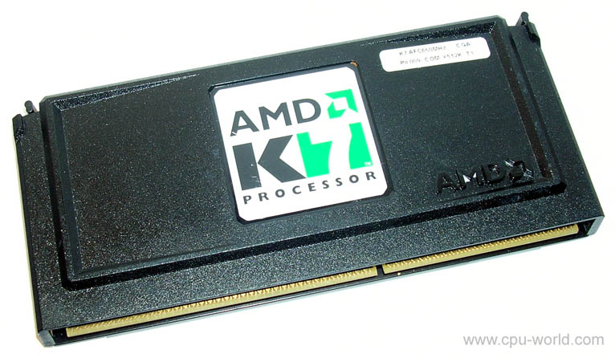
Code Name | Argon (K7) | Pluto, Orion (K75)
Date | June 1999 | November 1999
Architecture | 32-bit | 32-bit
Data Bus | 32-bit | 32-bit
Address Bus | 32-bit | 32-bit
Maximum Memory Support | 4 GB | 4 GB
L1 Cache | 64 KB + 64 KB | 64 KB + 64 KB
L2 Cache | 512 KB (1/2 CPU) | 512 KB (1/2, 2/5, 1/3 CPU)
Clock Speed | 500 - 700 MHz | 550 - 850 MHz (Pluto)
Clock Speed | 500 - 700 MHz | 900 - 1000 MHz (Orion)
FSB | 100 MHz (DDR) | 100 MHz (DDR)
SIMD | MMX, Enhanced 3DNow! | MMX, Enhanced 3DNow!
Fab | 250 nm | 180 nm
Transistor Count | 22 Million | 22 Million
Power Consumption | 42 - 50 W | 31 - 65 W
Voltage | 1.6 V | 1.6 - 1.8 V
Die Area | 184 mm² | 102 mm²
Socket | Slot A | Slot A
AMD K7: Athlon Thunderbird
Not long after the release of AMD's Athlon on Slot A and Intel's Pentium II and III for Slot 1, the industry realized that the lackluster performance of the L2 cache was hampering CPU performance. To overcome this issue, AMD reverted back to a traditional processor package with its Athlon Thunderbird, which contained L2 cache integrated directly onto the CPU die. Although the L2 cache size was cut in half, it ran at the same speed as the CPU, drastically improving performance.
Thanks to a maturing 180 nm process and higher yields, AMD also took this opportunity to boost the clock speed of its CPUs by 400 MHz.
K7: AMD Duron
To target the entry-level segment and to make use of its lower yield chips, AMD introduced the Duron product line. These processors used the same architecture but generally ran at lower clock speeds. AMD also disabled all but 64 KB of the L2 cache on these processors, which reduced performance, but the Duron still was quite competitive against Intel's Celeron products.
AMD K7: Athlon Palomino/XP
In 2001, AMD improved the Athlon again with the Palomino/XP. Little changed between the Thunderbird and the Palomino/XP, but the ever-maturing 180 nm process enabled AMD to push clock speeds up another 333 MHz. It also added support for the SSE SIMD instruction set. Microsoft's Windows XP launched around the same time, so AMD added "XP" to the Palomino code name to help advertise it towards users of the new operating system.
Versions of the Athlon Palomino/XP were also sold under the name "Athlon MP" for servers and "Athlon 4" or "Athlon XP Mobile" for laptop computers.
Thoroughbred And Barton
In 2002, AMD rolled out the Athlon Thoroughbred, which was produced on a new 130nm process. This helped lower power consumption push frequencies over 2 GHz. As the process matured, AMD introduced the Barton a year later. Barton brought a modest clock rate increase, and it also doubled the size of the L2 cache and added support for 200 MHz FSB and 400 MHz DDR RAM.
AMD K7: Athlon Thorton And Duron
Alongside Barton, AMD released two lower-end processors, the Athlon Thorton and a new Duron. Both processors used the same die as Barton but with part of the L2 cache disabled.
Thorton had 256 KB of L2 cache. similar to older Athlon processors, and it ran at slightly lower clock speeds than Barton. Thanks to the new 130nm fab technology, it was also more energy efficient than the older Athlon CPUs. The new Duron chip was limited to 64 KB of L2 cache, just like the previous Duron processors, but it was available at clock speeds up to 1.8 GHz, making the high-end models considerably faster than their predecessors.
AMD K7: First Sempron
AMD released its first Sempron-branded products in 2004. Initially, they slid in between the high-end Athlon Barton processors and the low-end Duron, filling roughly the same space as the Athlon Thorton. The first few models used either Thorton or Thoroughbred cores with the full 256 KB of L2 cache. These chips were capped at slightly lower clock speeds, with the fastest SKUs clocked at 2 GHz.
Just a few months after Sempron was introduced, AMD released a new version based on the Barton core with the full 512 KB of L2 cache and a higher 2.2 GHz clock speed.

Тasks of laboratory work

1. Read the story of the company
2. Fill the table Fill in the table for K5, К6, К7 (Athlon, Duron, Athlon Palomino, Athlon Thorton And Duron, Sempron), К75 :

Аrchitecture of the AMD company
Architecture name (Code Name) | Date (year) | Fab | Socket | Memory | Cache | Technologies, instructions

3. Аnswer the teacher's question

