AMD’s К8-Bulldozer

AMD K8
Just as it did two years prior, AMD pulled another shocker in 2005 with the introduction of a consumer-oriented dual-core processor based on the K8 architecture. Although the two processors were incapable of working on the same thread simultaneously, the second CPU core could handle other tasks and increase multitasking performance.
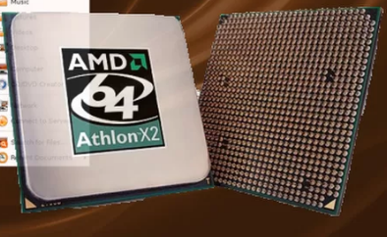
AMD produced a total of six CPU configurations in the Athlon 64 X2 product line, but the first five are all relatively similar to each other, varying only in L2 cache size and clock rate. The sixth Athlon 64 X2 design was the fastest in the series and the most energy efficient, owing to the move to 65nm transistor technology.
AMD Athlon 64 X2
Code Name | Manchester - Windsor | Brisbane
Date | 2005-2006 | 2006
Architecture | 64-bit | 64-bit
Data Bus | 64-bit | 64-bit
Address Bus | 64-bit | 64-bit
Maximum Memory Support | 1 TB | 1 TB
L1 Cache | 64 KB + 64 KB Per Core | 64 KB + 64 KB Per Core
L2 Cache | 256 KB - 1 MB Per Core (Full Speed) | 512 KB Per Core (Full Speed)
Clock Speed | 2 - 3.2 GHz | 1.9 - 3.1 GHz
Memory Controller | Dual-Channel DDR/DDR2 | Dual-Channel DDR2
HyperTransport | 1000 MHz | 1000 MHz
SIMD | MMX, Enhanced 3DNow!, SSE, SSE2, SSE3 | MMX, Enhanced 3DNow!, SSE, SSE2, SSE3
Fab | 90 nm | 65 nm
Transistor Count | N/A | N/A
Power Consumption | 35 - 125 W TDP | 65 - 89 W TDP
Voltage | 1.25 - 1.4 V | 1.25 - 1.35 V
Die Area | N/A | 126 mm²
Socket | Socket 939, Socket AM2 | Socket AM2

AMD K8: Turion And Turion X2
AMD introduced a new mobile product line called "Turion" in 2005. These processors used the same architecture as AMD's desktop product, but thanks to careful core binning, they were able to operate with less power. AMD introduced dual-core variants as well, dubbed "Turion X2."
AMD K8 Turion and Turion X2
Code Name | Turion (Lancaster, Richmond, Sable) | Turion X2
Date | 2005 - 2008 | 2006 - 2008
Architecture | 64-bit | 64-bit
Data Bus | 64-bit | 64-bit
Address Bus | 64-bit | 64-bit
Maximum Memory Support | 1 TB | 1 TB
L1 Cache | 64 KB + 64 KB | 64 KB + 64 KB
L2 Cache | 512 KB - 1 MB (Full Speed) | 256 KB - 1 MB Per Core (Full Speed)
Clock Speed | 1.6 - 2.4 GHz | 1.6 - 2.5 GHz
Memory Controller | Single-Channel DDR / Dual-Channel DDR2 | Dual-Channel DDR2
HyperTransport | 800 MHz / 1000 MHz | 800-1000 MHz
SIMD | MMX, Enhanced 3DNow!, SSE, SSE2, SSE3 | MMX, Enhanced 3DNow!, SSE, SSE2, SSE3
Fab | 65 - 90 nm | 65 - 90 nm
Transistor Count | N/A | N/A
Power Consumption | 25 - 35 W | 31 - 35 W
Voltage | 0.8 - 1.35 V | N/A
Die Area | N/A | N/A
Socket | Socket 754 / Socket S1 | Socket S1

AMD K10: Quad-Core Phenom
AMD's next architecture, K10, was a rather ambitious design. It is closely related to the K8, but it had several enhancements to the core and associated cache and memory controller. IPC was improved compared to K8, but K10's greatest advantage was its quad-core design that enabled it to run laps around the K8 dual-core CPUs in heavily-threaded applications.
Unfortunately, the K10 ran into problems early on. The first K10 processors were based on the Barcelona configuration and sold as Opteron server processors. But a flaw in Barcelona (known as the TLB bug) could cause the CPU to lock up. AMD was able to release a software patch to keep the TLB bug at bay. However, it imposed a sizable performance hit. Owing to the power requirements to run multiple CPU cores simultaneously, the K10 Phenom processors also struggled to run at higher clock speeds. The fastest quad-core model was limited to 2.6 GHz, whereas dual-core K10 processors sold under the Athlon brand name manged to reach just 2.8 GHz.
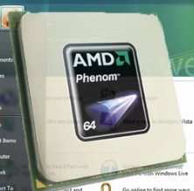
It should be noted that all first-generation K10 processors used the Agena die with part of the core disabled. Toliman, the triple-core variant, is actually the Agena die with one core disabled. The dual-core die was codenamed "Kuma," which is an Agena die with two cores disabled. Barcelona is identical to the Agena die as well, except that AMD fixed the TLB bug on Agena before releasing them to retailers. They were sold under the "Phenom," "Opteron" and "Athlon" product lines.
AMD Phenom
Code Name | Agena | Toliman
Date | November 2007 | March 2008
Architecture | 64-bit | 64-bit
Data Bus | 64-bit | 64-bit
Address Bus | 64-bit | 64-bit
Maximum Memory Support | 1 TB | 1 TB
L1 Cache (Per Core) | 64 KB + 64 KB | 64 KB + 64 KB
L2 Cache (Per Core) | 512 KB (Full Speed) | 512 KB (Full Speed)
L3 Cache (Shared) | 2 MB (@HyperTransport Frequency) | 2 MB (@HyperTransport Frequency)
Clock Speed | 1.8 - 2.6 GHz | 1.9 - 2.5 GHz
Memory Controller | Dual-Channel DDR2-1066 | Dual-Channel DDR2-1066
HyperTransport | 2000 MHz | 2000 MHz
Core Count | 4 | 3
SIMD | MMX, Enhanced 3DNow!, SSE, SSE2, SSE3, SSE4a | MMX, Enhanced 3DNow!, SSE, SSE2, SSE3, SSE4a
Fab | 65 nm | 65 nm
Transistor Count | 450 Million | 450 Million
Power Consumption | 65 - 140 W (TDP) | 65 - 95 W (TDP)
Voltage | 1.25 - 1.3 V | 1.25 V
Die Area | 285 mm² | 285 mm²
Socket | Socket AM2/AM2+ | Socket AM2+

AMD K10: Athlon II
AMD also released a series of low-end K10 processors branded Athlon II. To keep production costs low, these processors used CPU dies without L3 cache. The quad-core die was code-named Propus, and the dual-core was called Regor. A triple-core model called Rana used defective Propus dies with a single core disabled.
AMD also used Deneb cores, but with the L3 cache disabled. This hurt performance, but with several CPU cores and clock speeds around 3 GHz, they still offered a reasonable experience.
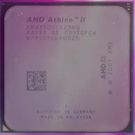
Because L3 cache increased power consumption of the CPU as a whole, AMD also sold several Propus and Regor dies as mobile Phenom II and Athlon II processors.
AMD Athlon II
Code Name | Propus | Regor
Date | September 2009 | June 2009
Architecture | 64-bit | 64-bit
Data Bus | 64-bit | 64-bit
Address Bus | 64-bit | 64-bit
Maximum Memory Support | 1 TB | 1 TB
L1 Cache (Per Core) | 64 KB + 64 KB | 64 KB + 64 KB
L2 Cache (Per Core) | 512 KB (Full Speed) | 1 MB (Full Speed)
L3 Cache (Shared) | None | None
Clock Speed | 2.2 - 3.2 GHz | 2.8 - 3.6 GHz
Memory Controller | Dual-Channel DDR2-1066, Dual-Channel DDR3-1333 | Dual-Channel DDR2-1066, Dual-Channel DDR3-1333
HyperTransport | 2000 MHz | 2000 MHz
Core Count | 4 | 2
SIMD | MMX, Enhanced 3DNow!, SSE, SSE2, SSE3, SSE4a | MMX, Enhanced 3DNow!, SSE, SSE2, SSE3, SSE4a
Fab | 45 nm | 45 nm
Transistor Count | N/A | 234 Million
Power Consumption | 45 - 95 W TDP | 25 - 65 W TDP
Voltage | 1.4 V | 1.4 V
Die Area | N/A | 117 mm²
Socket | Socket AM2+/AM3 | Socket AM2+/AM3

AMD Bulldozer: Zambezi
In October 2011, AMD introduced the successor to its K10 architecture, code-named "Bulldozer." With Bulldozer, AMD attempted to use high core count and clock speed to outperform Intel's recently-released Sandy Bridge. The cost of this clock rate-focused design, however, was a marked drop in IPC compared to the K10 architecture, and the design has been plagued with problems. The first Bulldozer chip, code-named Zambezi, was not able to cleanly out-perform Thuban Phenom II X6 CPUs, let alone beat Sandy Bridge. Part of the problem came from the use of a Multi-Core Module (MCM) that contains two integer cores and one FPU. As the two integer execution units have to share the FPU, this can lead to stalls in the pipeline.
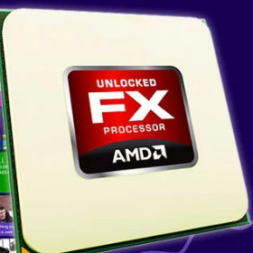
The design has also been criticized for being power-hungry and running too hot, though that stems from direct comparisons between Bulldozer and Sandy Bridge.
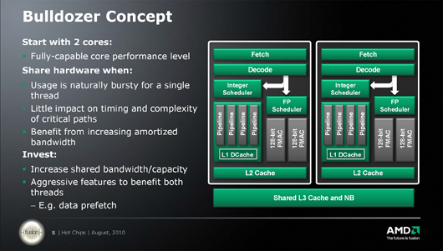

AMD Bulldozer Zambezi
Code Name | Zambezi
Date | October 2011
Architecture | 64-bit
Data Bus | 64-bit
Address Bus | 64-bit
Maximum Memory Support | 1 TB
L1 Cache (Per Module) | 64 KB + (2 x 16 KB)
L2 Cache (Per Module) | 2 MB (Full Speed)
L3 Cache (Shared) | 8 MB
Clock Speed | 2.8 - 4.2 GHz (4.3 GHz Turbo)
Memory Controller | Dual-Channel DDR3-1866
HyperTransport | 2600 MHz
Core Count | 4, 6, 8
SIMD | MMX, SSE, SSE2, SSE3, SSSE3, SSE4a, SSE4.1/4.2, AVX
Instructions | AES, FMA4, XOP
Fab | 32 nm
Transistor Count | N/A
Power Consumption | 95 - 125 W
Voltage | 0.95 - 1.4125 V
Die Area | 316 mm²
Socket | AM3+

AMD Piledriver: Trinity And Richland

A year after Bulldozer debuted, AMD released a revised architecture known as Piledriver. Piledriver was initially released with Trinity, the company's second-gen APU. It saw clock speed increase by about 10 percent, and that, in conjunction with architectural enhancements, pushed performance up by roughly 15 percent without increasing power consumption.
On the iGPU side, Trinity moved to the TeraScale 3 architecture used inside of AMD's Radeon HD 6900-series GPUs. This helped to increase graphics performance over Llano.
Richland, in turn, was a slightly improved Piledriver part. It performed just slightly better than Trinity due to higher clock speeds. It also managed to reduce power consumption and heat somewhat. The performance gap between mobile Trinity APUs and mobile Richland APUs was greater than on the desktop, owing to the improved thermals and power consumption.

AMD Piledriver: Vishera

AMD also applied its Piledriver architecture to the FX family, displacing Zambezi in favor of Vishera.
AMD Bulldozer Vishera
Code Name | Vishera
Date | October 2012
Architecture | 64-bit
Data Bus | 64-bit
Address Bus | 64-bit
Maximum Memory Support | 1 TB
L1 Cache (Per Module) | 64 KB + (2 x 16 KB)
L2 Cache (Per Module) | 2 MB (Full Speed)
L3 Cache (Shared) | 8 MB
Clock Speed | 3.3 - 4.7 GHz (5 GHz Turbo)
Memory Controller | Dual-Channel DDR3-1866
HyperTransport | 2600 MHz
Core Count | 4, 6, 8
SIMD | MMX, SSE, SSE2, SSE3, SSSE3, SSE4a, SSE4.1/4.2, AVX
Instructions | AES, BMI1, F16C, FMA3, FMA4, TBM, XOP
Fab | 32 nm
Transistor Count | N/A
Power Consumption | 95 - 125 W (220 W)
Voltage | 0.875 - 1.425 V
Die Area | N/A
Socket | AM3+

AMD Steamroller: A GCN APU

In 2014, AMD updated its APU line again with the new Steamroller architecture. AMD shifted to a new 28nm process that favored chip density over clock speeds in order to be more compatible with its graphics technology. The CPU demonstrated a reasonable increase in IPC over its predecessor, thanks in part to a larger L1 cache and additional internal registers. It wasn't able to hit the same clock speeds as Richland though, so overall performance didn't increase much.
The graphics side of the APU improved drastically, however, owing to the new transistor technology, an increase in shader count, and a move to AMD's GCN GPU architecture. The APU featured a number of other enhancements, such as being the first HSA-compatible APU, the addition of AMD's TrueAudio DSP technology and support for PCIe 3.0.
The first Steamroller APUs use a configuration known as Kaveri. The APU line was later refreshed with Godavari, which benefits mostly from higher clock speeds.

Excavator: The End Of Bulldozer
The last architecture that AMD plans to produce based on Bulldozer is known as Excavator, which is used inside of AMD Carrizo-based APUs. Relatively few of these products have been released thus far, so we can't be sure what the clock speed limit will be on these parts. Carrizo is designed to have significantly higher transistor density (than prior Bulldozer-based processors), which helps to reduce the die area and lower power consumption. AMD reworked the cache inside of Excavator, too.
The processor has less L2 cache, but twice as much L1 cache when compared to Steamroller. Because the L1 cache is several times faster than the L2 cache, this helps to boost IPC performance. The branch prediction target buffer was increased by 50 percent as well, to 768 KB, which further helps to improve performance. The graphics processor also gained 512 KB of dedicated L2 cache to increase graphics processing power. Rearranging the cache on the APU also helped to lower the power consumption, as cache tends to be fairly power hungry, and this new configuration has less overall cache on die.
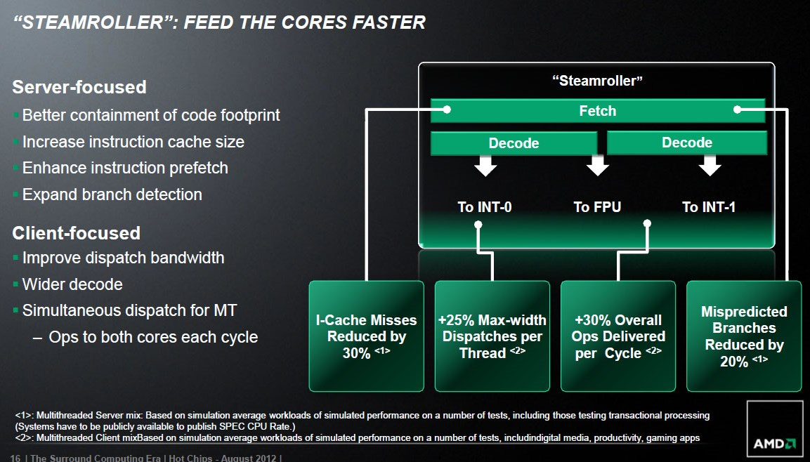
Тasks of laboratory work

1. Read the story of the company
2. Fill the table Fill in the table for K5, К6, К7 (Athlon, Duron, Athlon Palomino, Athlon Thorton And Duron, Sempron), К75 :

Аrchitecture of the AMD company
Architecture name (Code Name) | Date (year) | Fab | Socket | Memory | Cache | Technologies, instructions

3. Аnswer the teacher's question

